**CS 255 System Design Document: DriverPass System**

**UML Diagrams**

**UML Use Case Diagram**

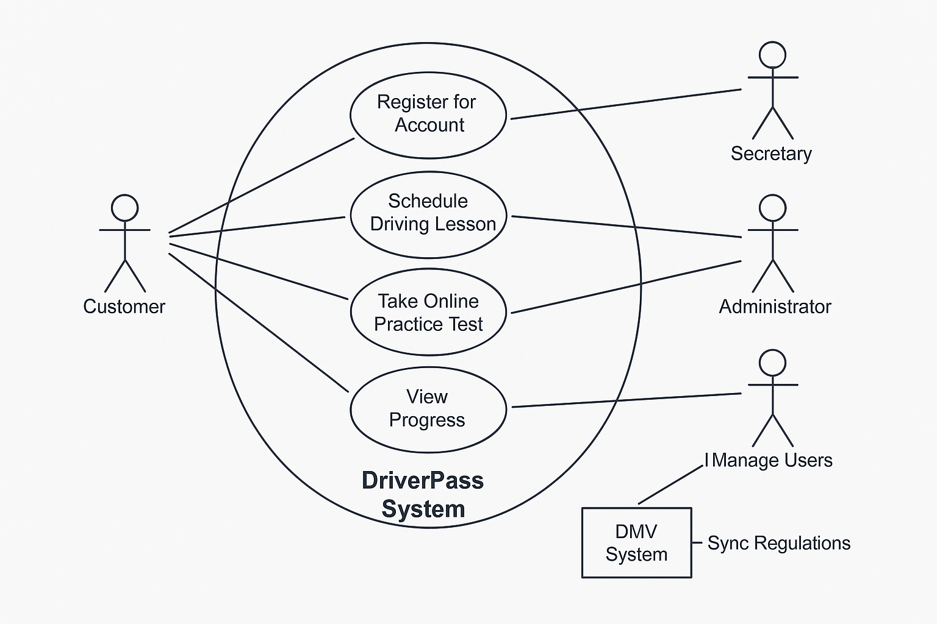

This diagram outlines interactions between the system and various users: Customers, Secretaries, Administrators, and the DMV System. Core use cases include registering accounts, scheduling lessons, taking practice tests, viewing progress, and managing system users.

**UML Activity Diagrams**

**1. Activity Diagram: Schedule Driving Lesson**

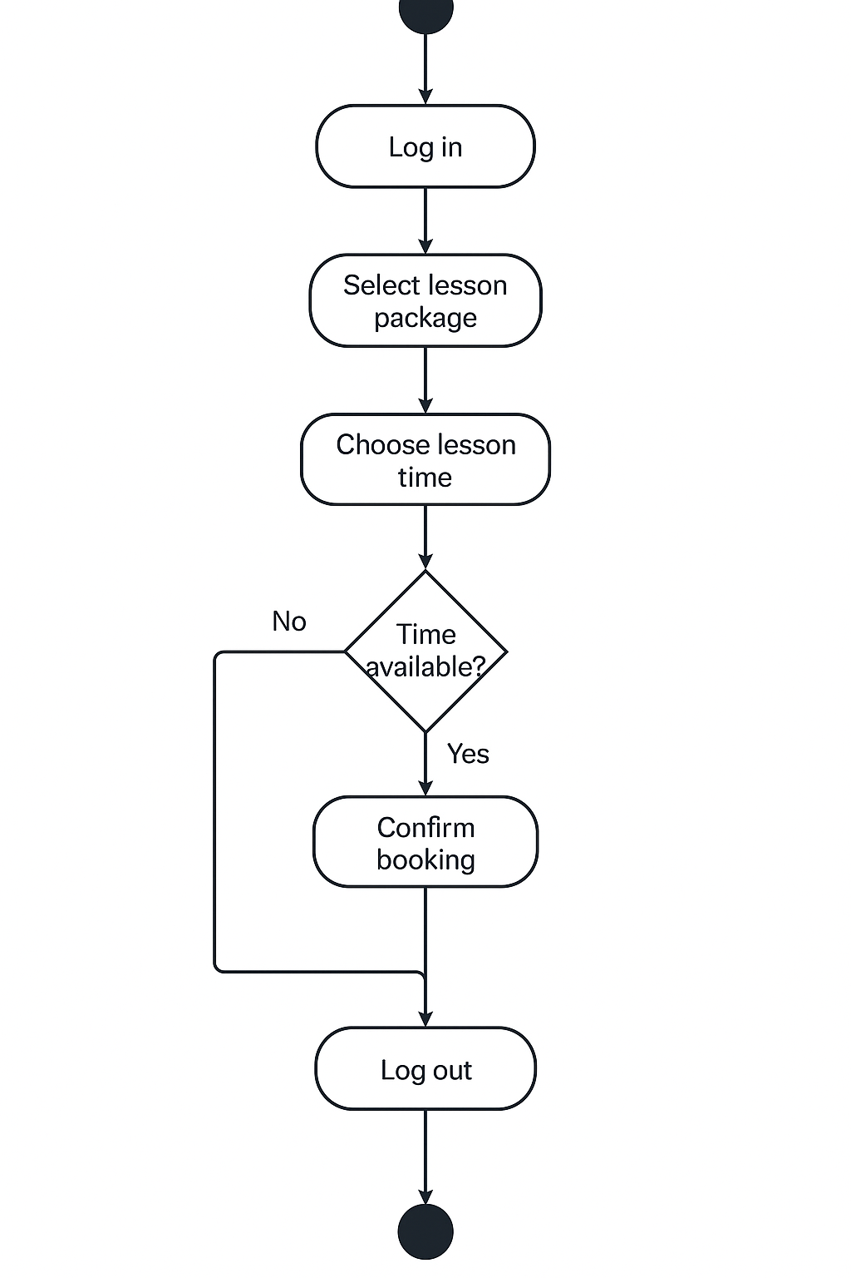

* This diagram shows the steps a customer takes to schedule a lesson, including login, viewing available times, selecting a slot, and confirming the appointment.

**2. Activity Diagram: Take Online Practice Test**

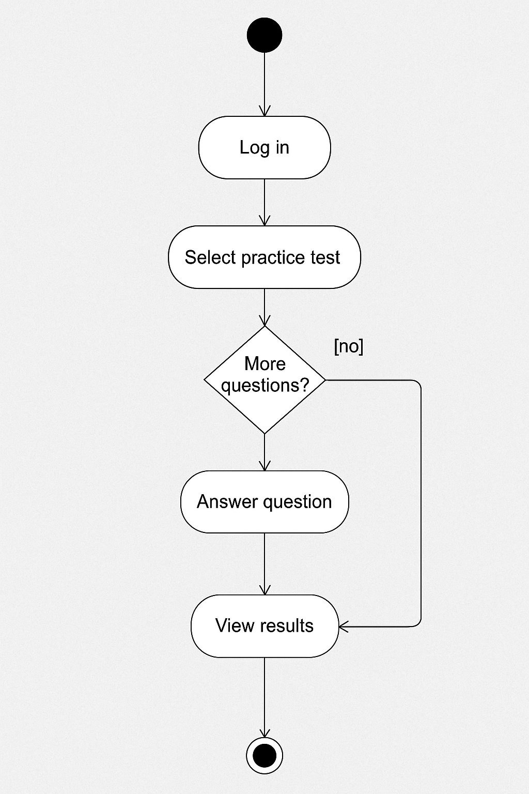

This diagram shows the customer workflow for logging in, accessing a test, answering questions, submitting, and receiving feedback.

**UML Sequence Diagram**

**Use Case: Schedule Driving Lesson**

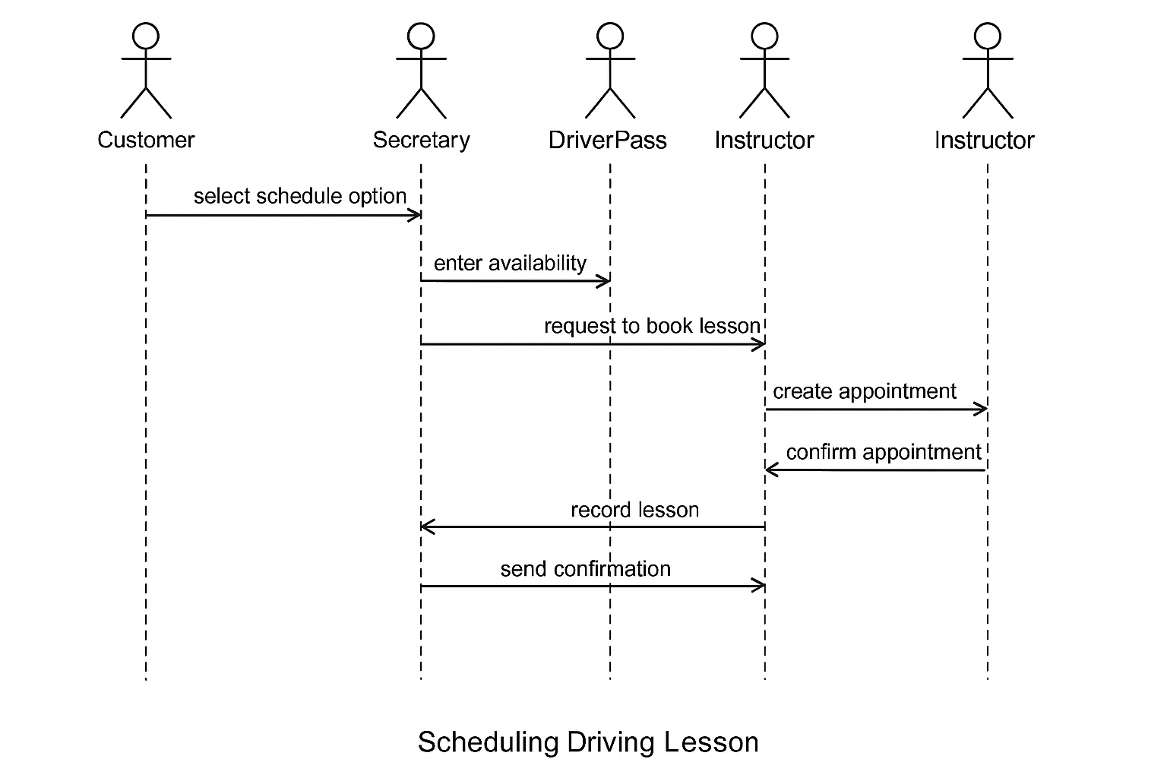

* This sequence diagram details the interaction between the customer, system interface, scheduling module, and database as a lesson is booked and confirmed.

**UML Class Diagram**

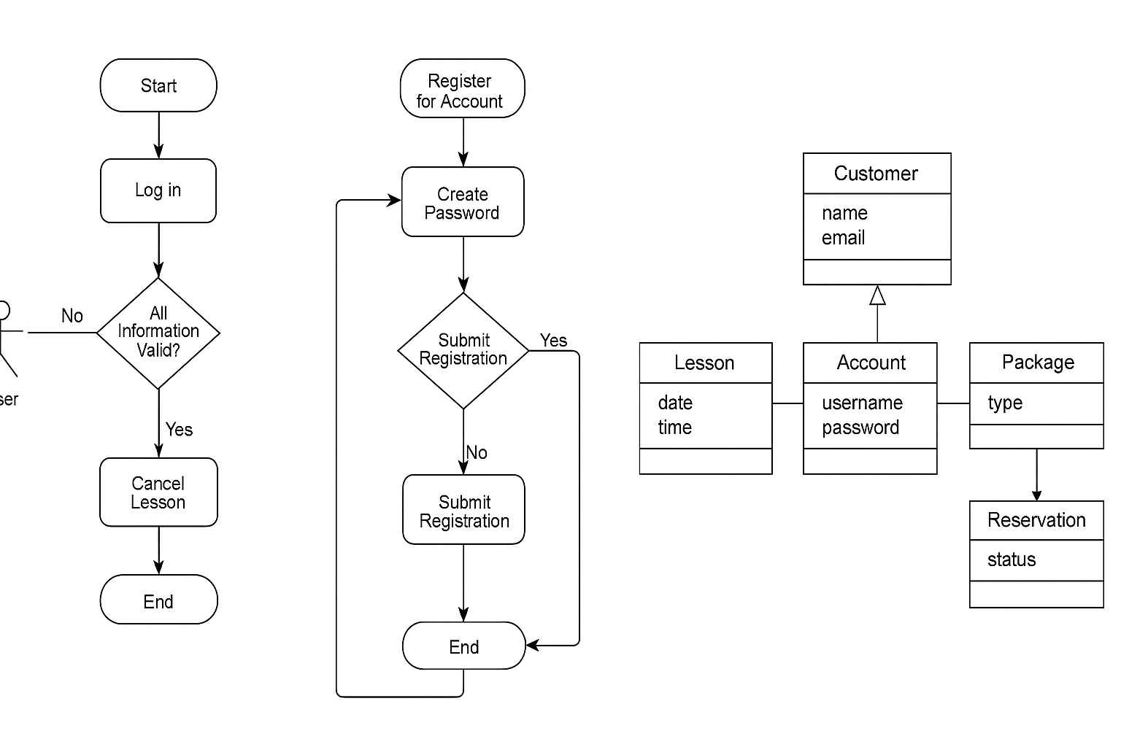

This diagram includes classes for Customer, Admin, Schedule, Payment, PracticeTest, and DMVIntegration, with attributes like customerID, lessonDate, testScore, and associations reflecting the relationships among these components.

**Technical Requirements**

**Hardware:**

* Cloud-hosted virtual servers with load balancing for scalability.
* Secure HTTPS endpoints for client-server communication.
* Optional on-site terminals for staff use (desktop or tablet).

**Software:**

* Web-based interface built on HTML5/CSS/JS frontend.
* Backend developed using Python with Flask or Node.js.
* MongoDB or PostgreSQL for storing user accounts, appointments, and test scores.
* API integration layer for DMV updates.

**Tools:**

* Lucidchart for modeling.
* Git for version control.
* VSCode or JetBrains IDEs for development.
* Selenium for automated testing.

**Infrastructure:**

* AWS or Azure deployment with auto-scaling.
* OAuth 2.0 for secure user authentication.
* Role-based access control for customer, admin, secretary, and IT roles.
* Daily cloud backups.

This system design blends object- and process-modeling to deliver a scalable, secure, and easy-to-use experience that fully supports DriverPass’s core mission: helping more students pass their driving tests through a mix of self-paced online training and real-world driving instruction.